Chapter 10, Solution 48.

Find i_{o} in the circuit in Fig. 10.93 using superposition.

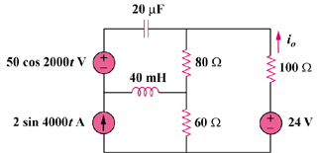

Figure 10.93
For Prob. 10.48.

Solution

Let , where is due to the ac voltage source, is due to the dc voltage source, and is due to the ac current source. For , consider the circuit in Fig. (a).

(a)

I

100

-j25

500 V
+

j80

60

80

I_{O1}

Using current division,
Hence,

For , consider the circuit in Fig. (b).

i_{O2}

24 V

80

100
+

60

(b)

For , consider the circuit in Fig. (c).

`

I_{O3}

100

(c)

j160

-j12.5

20 A

I₃

I₁

I₂

60

80
For mesh 1,
(1)

For mesh 2,

Simplifying and substituting (1) into this equation yields
(2)

For mesh 3,

Simplifying and substituting (1) into this equation yields
(3)

Substituting (3) into (2) yields

Hence,

Therefore,
{0.1 + 0.217 cos(2000t + 134.1) – 1.1782 sin(4000t + 7.38)} A

